

**Web**

Development

**Page** 01

# what is



Web development : process of building, programming and maintaining websites and web applications.

web development we can develop:

**Front-end:** The surface level elements and things you can see in the user's browser like page layout, color schemes, etc.

**Back-end:** This is where you put all the technical elements behind the scenes of your site

**full stack :** the complete process of application software development, including both the front-end and back-end development

**Page** 02

The difference between

**2024**

# the Web and the internet

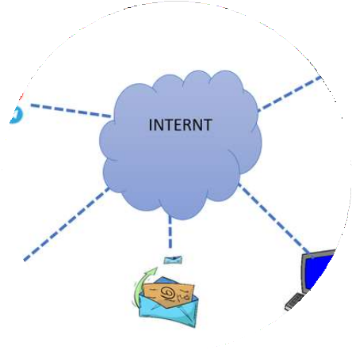

What is WWW (Web)?

WWW definition: WWW (World Wide Web) is one of the various services offered by the Internet in order to share information

**What is the Internet?**

Internet definition: The Internet is a network of networks, connected computers, servers, and countless devices from around the world on which the (WWW) web runs.

**Page** 03

# Key differences

between the web and the internet

* Internet is an infrastructure, whereas WWW is a service.
* WWW is more software-oriented, but the Internet is primarily based on hardware.
* WWW is a subset of the Internet. On the other hand, the Internet is a superset of [WWW.](http://WWW/)
* The Internet is independent, whereas WWW’s existence depends on the Internet.
* WWW is one of the various services offered by the Internet in order to share information. On the other hand, the Internet is a network of connected computers on which the web (WWW) runs.



**Page** 04

Jobs in



**Page** 08

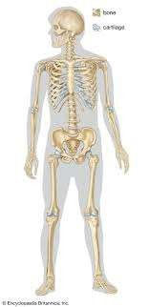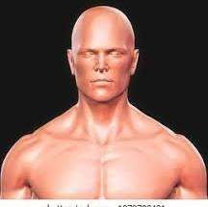

Web development

### Full-stack

A full-stack web developer is a person who can develop both client and server software. Full stack is divided into two parts :

**A- front-end**

1. html:

-hyper text markup language

-using for creating web pages and describe the structure of web pages.

1. css:

- CSS stands for Cascading Style Sheets

-describes how HTML elements are to be displayed on screen

1. javascript :programming language that allows you to implement complex features on web pages

Jobs in



Web development

### B- backend:

Server software:

1-php:

-stand for Hypertext Preprocessor

- scripting language

-PHP scripts are executed on the server (like XAMPP)

2-SQL:

-stands for Structured Query Language

-standard language for accessing databases

**Page** 08

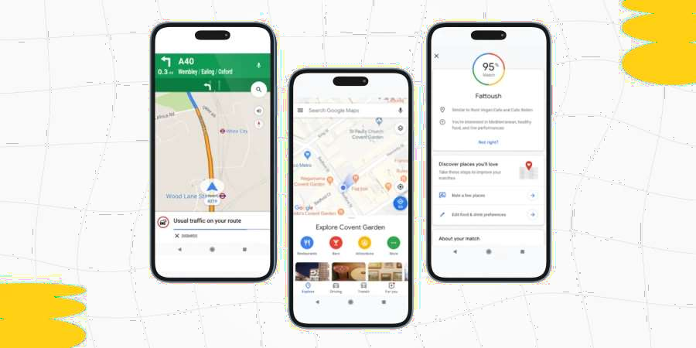

Ux (user experience): UX refers to the entire interaction you have with a product, including how you feel about the interaction

**Page** 08



Jobs in

Web development

###### UI/UX

Ui (user interface) : refers to the screens, buttons, toggles, icons, and other visual elements that you interact with when using a website, app, or other electronic device.

Jobs in



**Page** 08



Web development

Project Manager

LA project manager is a professional who organizes, plans, and executes projects while working within restraints like budgets and schedules. Project managers lead entire teams, define project goals, communicate with stakeholders, and see a project through to its closure.

**Tasks and responsibilities**

* Defining the scope of the project
* Staying on schedule
* Planning a project’s cost .
* Managing project resources (including teams and workers)
* Documenting the progress of the project
* Communicating with stakeholders

Jobs in



**Page** 08

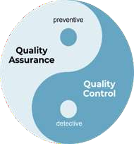

Web development

**Quality assuransce and Quality control**

quality assurance and quality control

QA: Focuses on improving processes to prevent problems before they arise.

QC: Focuses on inspecting the finished product to detect defects after it has been produced.

Jobs in



Web development

##### Mobile developer

People who design and prepare software for smartphones and other mobile devices are called mobile app

developers.

**Workplace**

A mobile app developer may work for large technology companies or small startups. Some developers work for

themselves from home.

**Mobile app developer salary**

The hourly wage for a mobile app developer varies widely from $21 to $150 per hour, depending on experience and location. The national average salary in 2018 was about $100,000 per year. But individual jobs may pay much more or much less.

**Soft Skills**

1. Patience
2. Good at working with other team members
3. Ability to work on several different projects at the same time

**Page** 08

Jobs in



Web development

##### Mobile developer

**Technical Skills**

\*\*\***Native** 1)Swift (ios)

2)Objective-c (ios) 3)Kotlin

4)Java

\*\*\***Frame Work**

1. Flutter
2. React Native (Js)

Jobs in



Web development

##### DevOps

:It’s a Software development methodology:

It accelerates the delivery of higher-quality applications and services by combining and automating the work of software development and IT operations teams. With shared tools and practices

·**Coding**: code development and unit testing

·**Building**: process of continually integrating work from multiple developers

·**Testing**: process of testing the new patches and finding bugs and errors in either code or the product

·**Packaging** :create packaging and patches that can be released

·**Configuration**

# Most popular

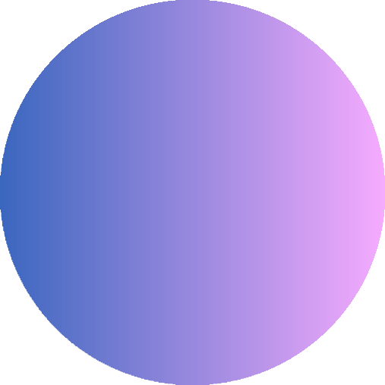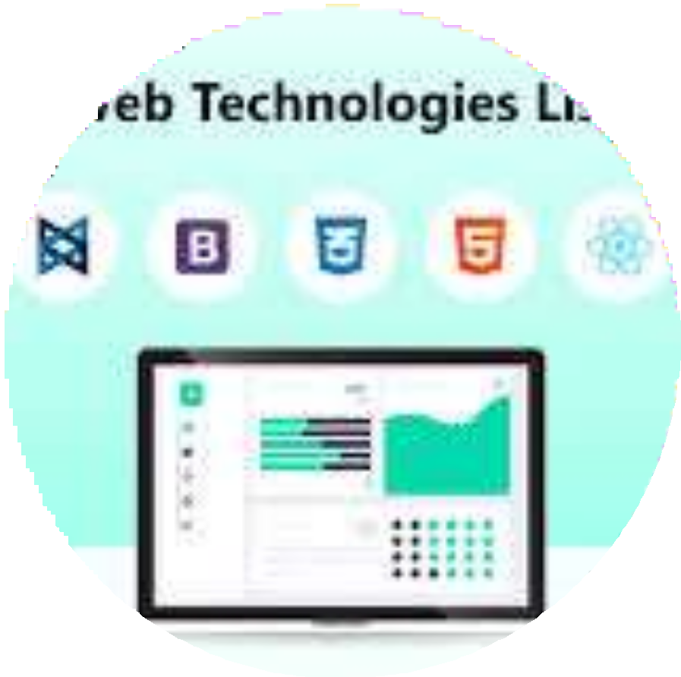

technologies in the web

The Most popular technologies on the web: When we are talking about web development technologies, it usually means the client-side technologies, which are used to build and display everything that the end- user interacts with. The main language of the web is JavaScript ,means that the web technologies are mostly based on JavaScript, while server-side technologies are varied (.NET, Java, PHP, Ruby, or even server-side JavaScript Node.js).

**Page** 09

# Popular web technologies

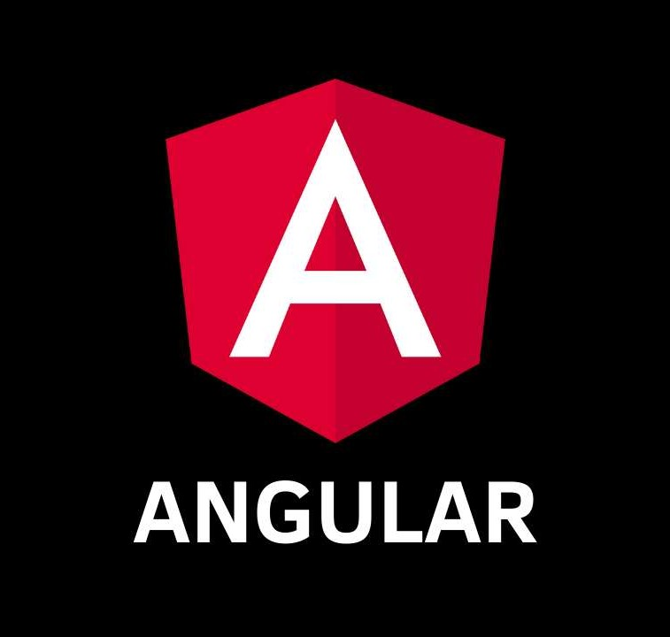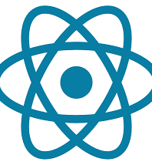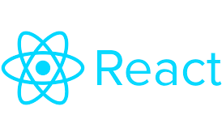

Angular: Angular is a TypeScript- based, open-source, front-end mobile and web application framework developed by Google in 2010.

React: React is an open-source, front-end JavaScript library for creating interactive UIs. React is developed and maintained by Facebook and a large community of dedicated developers.

**Page** 05

# Popular web technologies



## Vue.js:Vue.js is an open-source MVVM (Model-View-ViewModel), front-end JavaScript framework for building web UIs and single-page applications.

Flutter for web :Flutter’s a free, open- source mobile UI framework developed by Google for building fast and expressive native apps. Flutter can also be used for web content using standards-based web development technologies: HTML,

## CSS, and JavaScript.

**Page** 05

# Salaries in

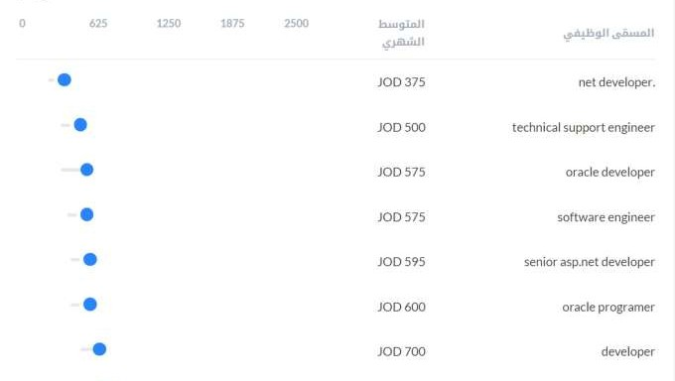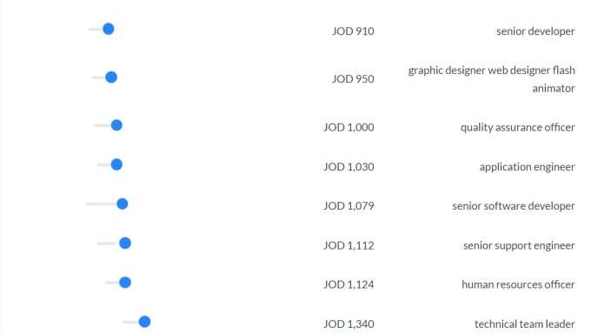

Web development

salaries in web development vary depending on years of experience and the position itself



**Page** 06

# Salaries in

Web development

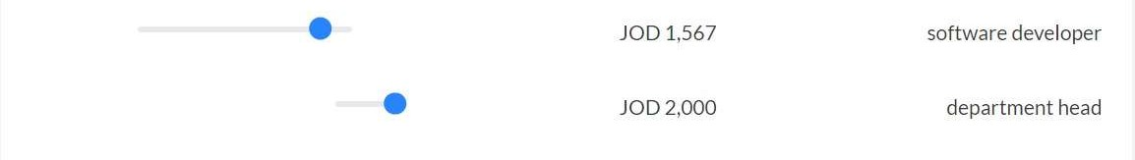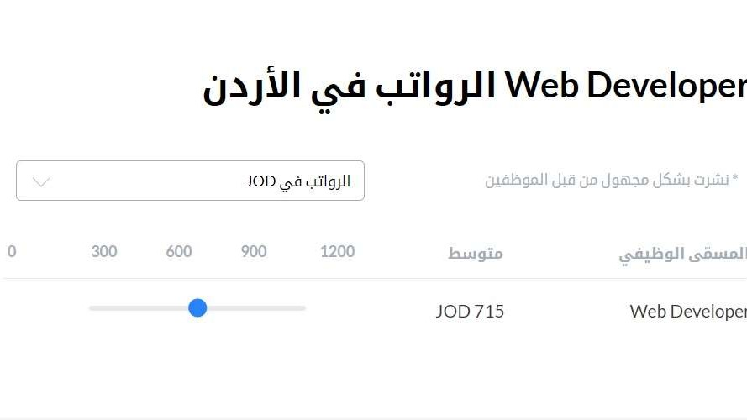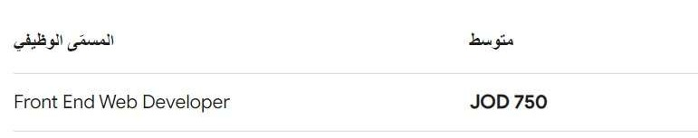

# Salaries in

Web development

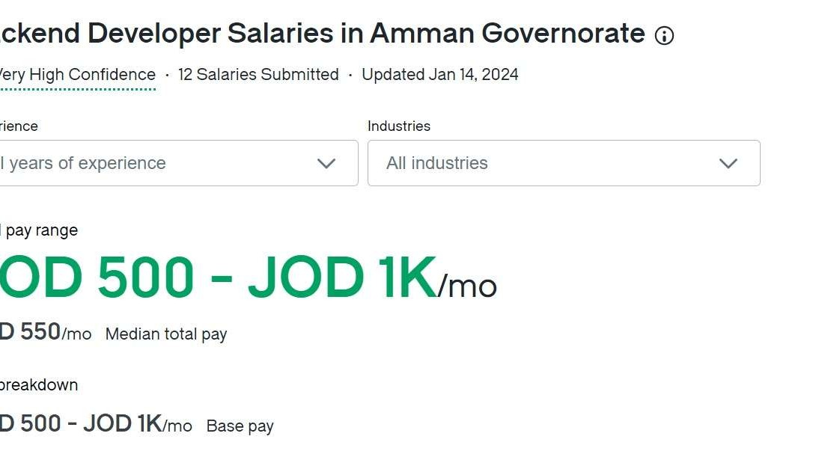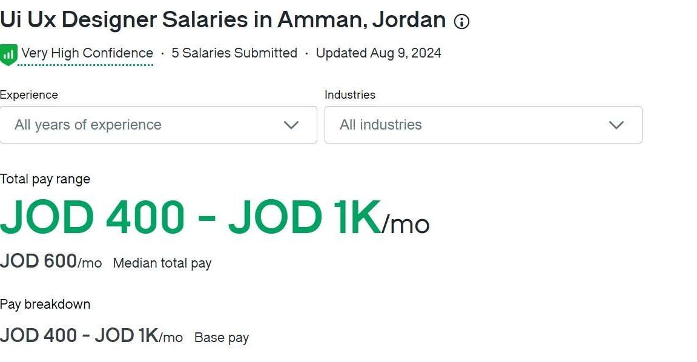

# Salaries in

Web development



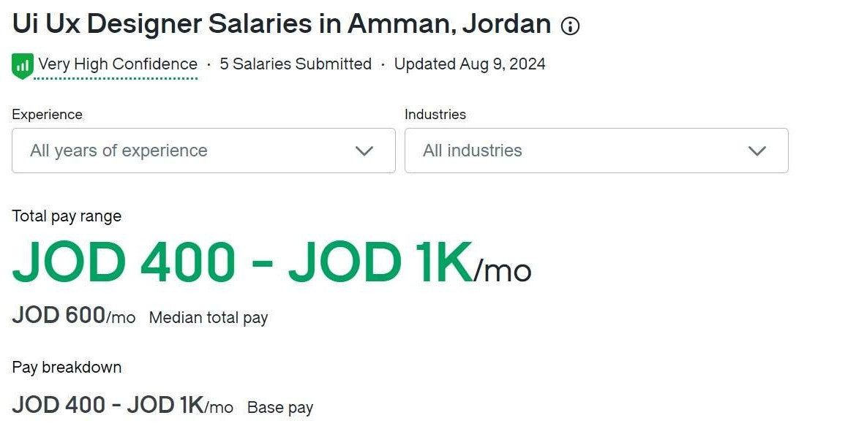

# Salaries in

Web development

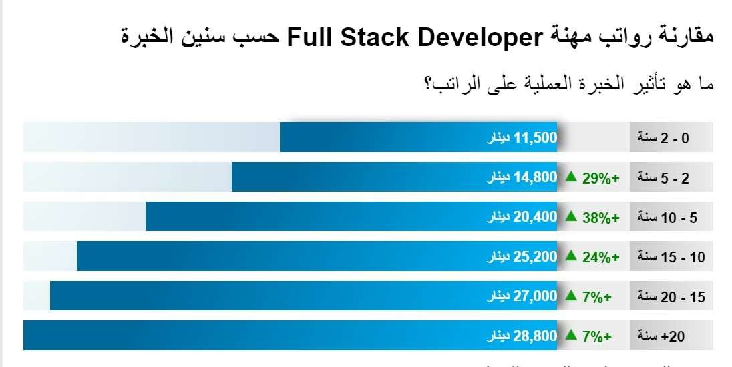

**Most demmanded** field in Web development

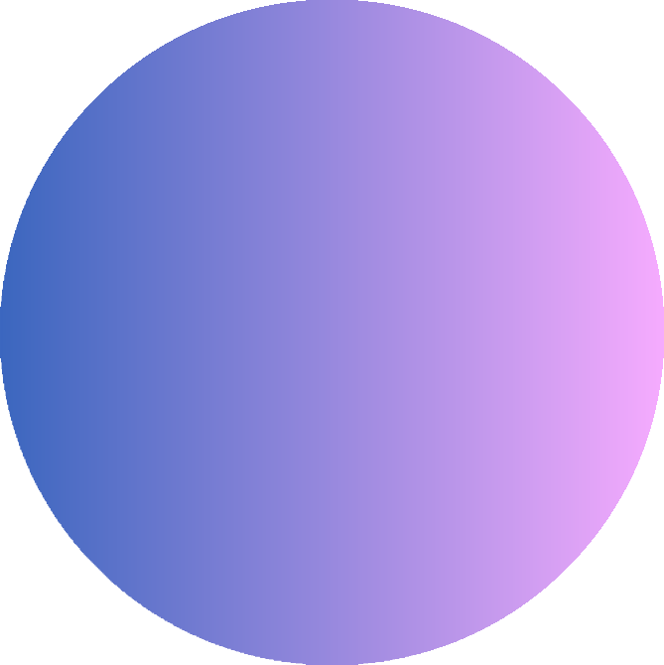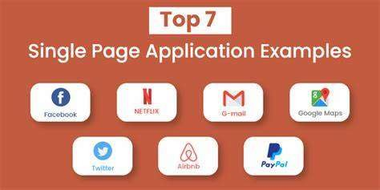

#### 1-Proficiency in javascript frameworks

it split into 3 frameworks;

1. react is used mostly for SPA (single page application)
2. Angular developed by google for dynamic web application (facebook google maps airbnb) 3-vue.js:Library for building interactive web interfaces using simple api view layer only and not full blown.

#### expertise in front end develpoment;

-HTML/CSS

-Responsive Design

-Beta test

**Page** 09

**Most demmanded** field in Web development



1. mastery of backend:

-Node.js

-Ruby on rails usage:

* Rendering HTML templates
* Updating databases
* Sending and receiving emails

-SQL

1. embracing new technologies in web development

-SPA

-PWA (progressive web apps) combining the best of web and mobile apps 6-brief understanding of UI/UX

7-block chain

Blockchain is an encrypted database storing system, Blockchain technology enables the participants to make transactions across the internet without the interference of a third party.

**Page** 09

Omar Ahmad Rania Husam Musa Oroub Loay



**Page** 10

**Thank**

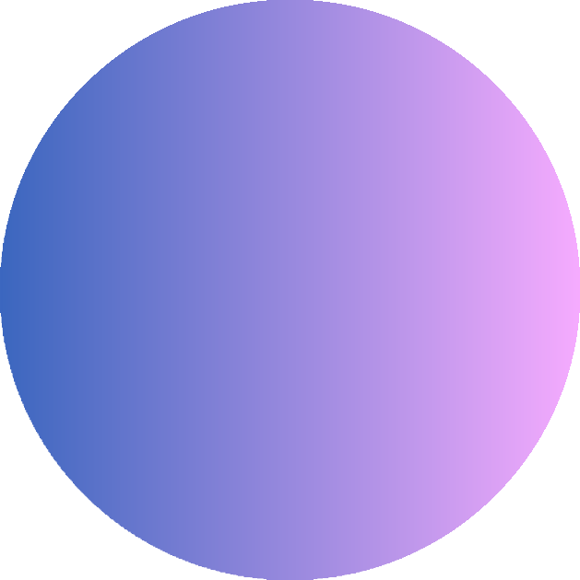You.